clear;clc;
Give signal x[n] and n from start point
x = [5 5 5 4 4 4 3 2 1 ]; % signal x[n]
n = [-1 0 1 2 ]; % values of n corresponding to x[n]
% matching the array sizes of x[n] and n
if numel(x)~=numel(n)
if numel(x)<numel(n)
x = [x zeros(1,(numel(n)-numel(x)))];
else
n = [n [n(numel(n))+1:n(numel(n))+(numel(x)-numel(n))]];
end
end
syms z
syms f(z)
f = z*0;
for i = 1:numel(x)
f = f + x(i)*z^(-n(i));
end
f = simplify(f)
f =
(5*z^8 + 5*z^7 + 5*z^6 + 4*z^5 + 4*z^4 + 4*z^3 + 3*z^2 + 2*z + 1)/z^7
%DTFT x axis
wresol = 0.01;
w = 0:wresol:4*pi;
c = exp(1j.*w);
myfunc = matlabFunction(f,'vars',z)
for i = 1:numel(c)
p(i) = myfunc(c(i));
end
myfunc =
function_handle with value:
@(z)1.0./z.^7.*(z.*2.0+z.^2.*3.0+z.^3.*4.0+z.^4.*4.0+z.^5.*4.0+z.^6.*5.0+z.^7.*5.0+z.^8.*5.0+1.0)
plotting the magnitude and phase
subplot(2,1,1)
plot(w,abs(p))
title('Magnitude of DTFT from z transform')
xlabel('---> w in radians from 0 to 4pi ')
ylabel('---> Magnitude of DTFT')
subplot(2,1,2)
plot(w,phase(p)*180/pi)
title('Phase of DTFT from z transform')
xlabel('---> w in radians from 0 to 4pi')
ylabel('---> Phase of DTFT')
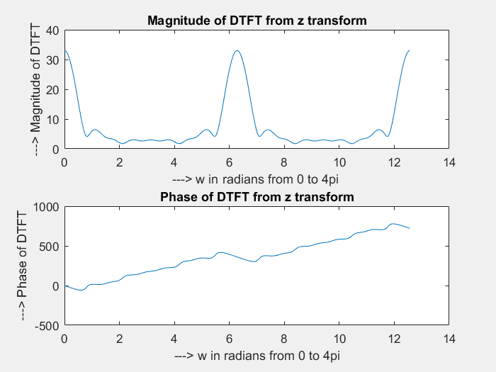
%{
The obtained DTFT is having a periodicity of 2pi
%}
Published with MATLAB® R2017a

